**

**A Project Report On**

**Automation Testing on Imagica Website**

**By**

**Divyani Sejkar**

**Batch: (2021-5334)**

**Course: School of Coding Certified Software Test Engineer**

**Under the Guidance of,**

**Priyanka Desale**

**(Technical Trainer)**

**EduBridge**

**Introduction**

This Project aims to do overall testing like functional testing, GUI testing on website to check quality of application. It helps to improve quality of website and saves time for manually doing this testing. In this project our main focus is to check functionalities available on website. Also, it includes title check and all links count with their working status.

**Software Requirements**

* Operating System: Windows 10
* Browser: Chrome Version 91.0.4472.124
* IDE: Eclipse IDE
* Automation Tool: Selenium WebDriver
* TestNg framework
* Front-end: Java
* Android phone galaxy s5
* iphone 6/7//8/plus

**Testcases**

**TC01 : Launch Browser and Open URL of Imagica Website**

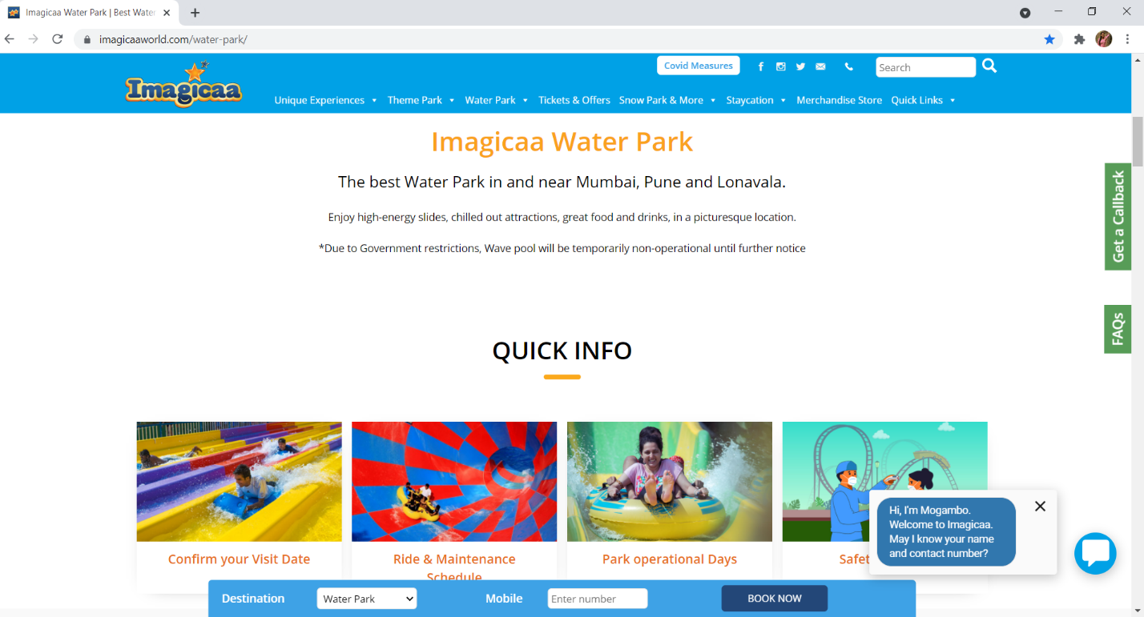

System.setProperty("webdriver.chrome.driver", "C:\\Users\\Divyani\\Desktop\\Selenium jar\\chromedriver.exe");

WebDriver w = new ChromeDriver();

w.get("https://www.imagicaaworld.com/water-park/");

w.manage().window().maximize();

Thread.sleep(2000);

**TC02 : Getting title of the website**

String title = w.getTitle();

System.out.println("Title of the website : "+title);



**TC03 : Getting URL of the website**

String URL = w.getCurrentUrl();

System.out.println("URL of the website : "+URL);



**TC04 : Mouse hover on navigation panes Unique Experiences**

JavascriptExecutor js = (JavascriptExecutor) w;

act = new Actions(w);

act.moveToElement(w.findElement(By.linkText("Unique Experiences"))).perform();

Thread.sleep(2000);

**TC05 : Taking screenshot of navigation mouse hover on Unique Experiences**

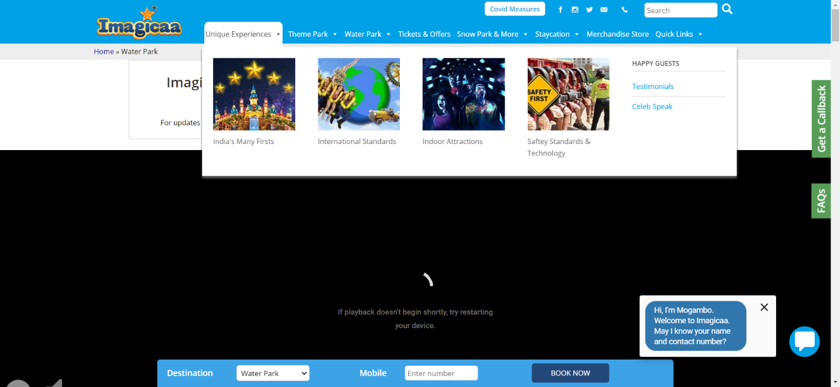

TakesScreenshot t = (TakesScreenshot) w;

File src = t.getScreenshotAs(OutputType.FILE);

Files.copy(src, new File ("D:\\Screenshots\\unique.png"));

**TC06 : Mouse hover on navigation panes Theme Park**

act.moveToElement(w.findElement(By.linkText("Theme Park"))).perform()

Thread.sleep(2000);

**TC07 : Taking screenshot of navigation mouse hover on Theme park**

File src1 = t.getScreenshotAs(OutputType.FILE);

Files.copy(src1, new File ("D:\\Screenshots\\theme.png"));

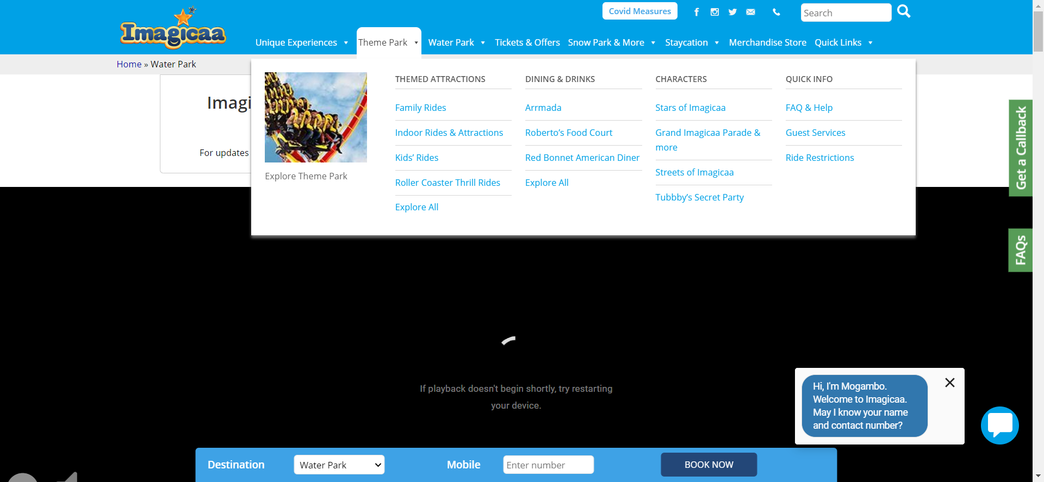

**TC08 : Click on “Explore All” link**

w.findElement(By.linkText("Explore All")).click();

Thread.sleep(4000);

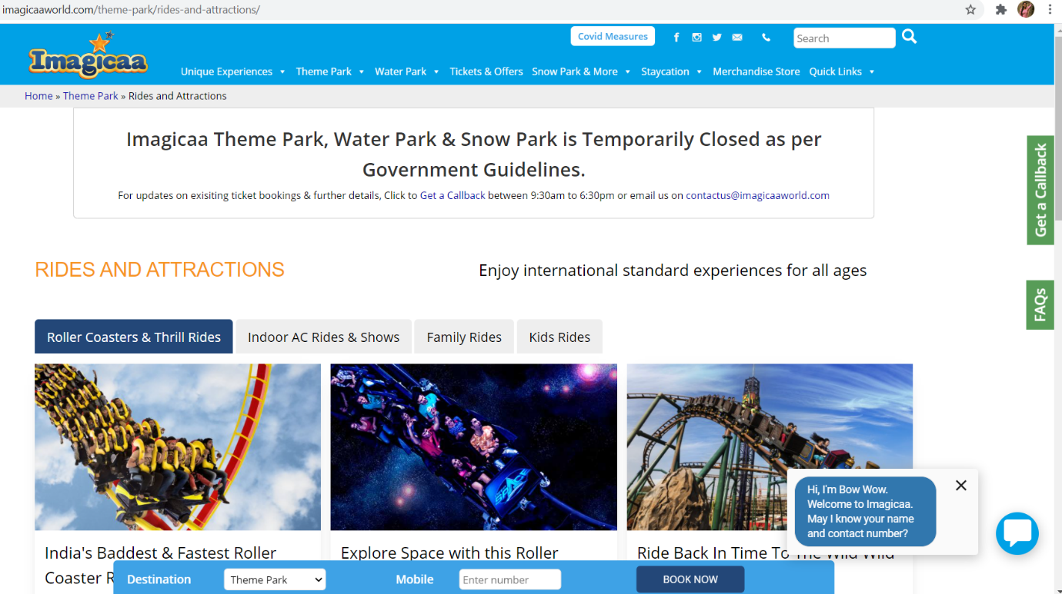

**TC09 : Scrolling rides and attractions page**

js.executeScript("window.scrollTo(0,400)");

Thread.sleep(2000);

js.executeScript("window.scrollTo(400,800)");

Thread.sleep(2000);

js.executeScript("window.scrollTo(800,0)");

Thread.sleep(2000);

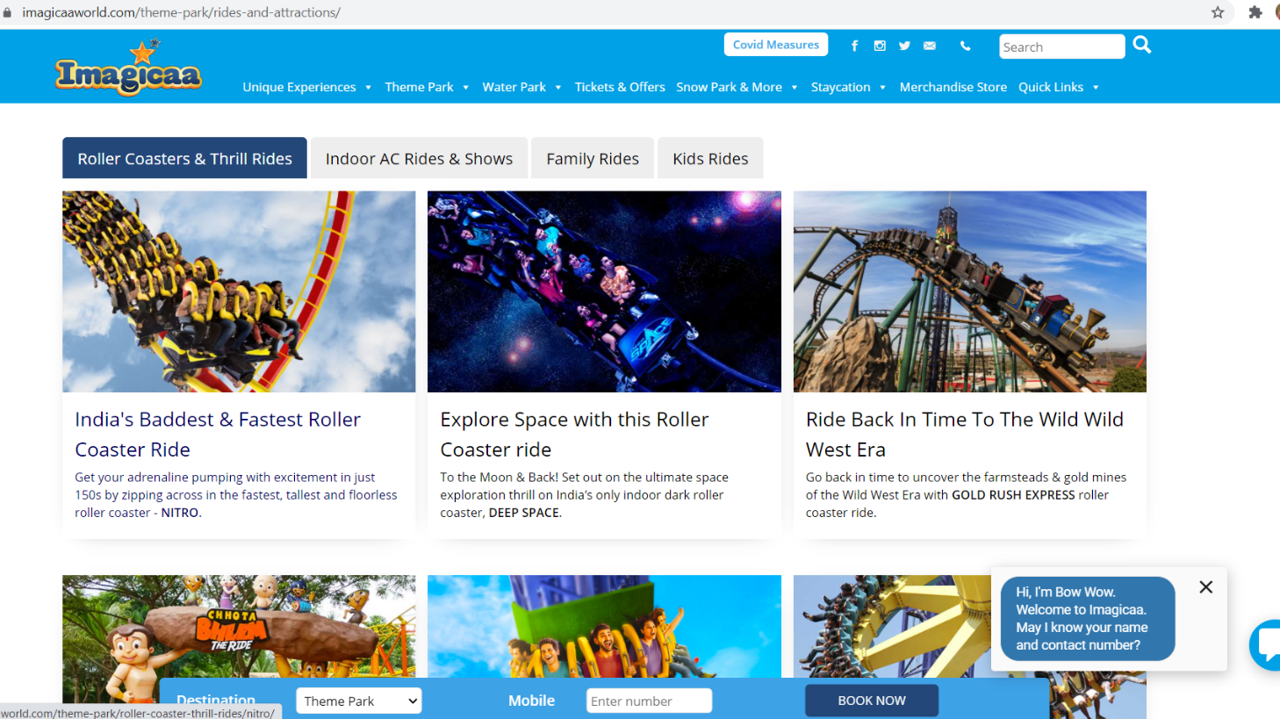

**TC10 : Click on Indoor ac rides and shows button**

w.findElement(By.xpath("/html[1]/body[1]/div[4]/div[8]/div[8]/main[1]/article[1]/div[1]/div[2]/div[1]/div[1]/button[2]")).click();

// Absolute xpath

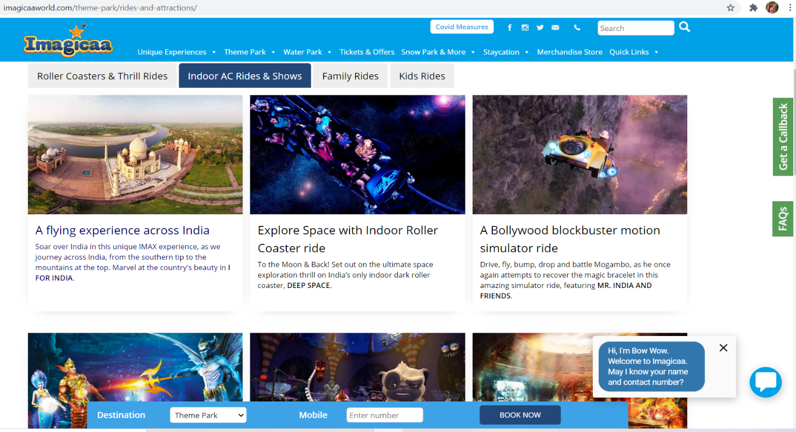

**TC11 :** **Scrolling indoor ac rides and shows**

js.executeScript("window.scrollTo(0,400)");

Thread.sleep(2000);

js.executeScript("window.scrollTo(400,800)");

Thread.sleep(2000);

js.executeScript("window.scrollTo(800,0)");

Thread.sleep(2000);

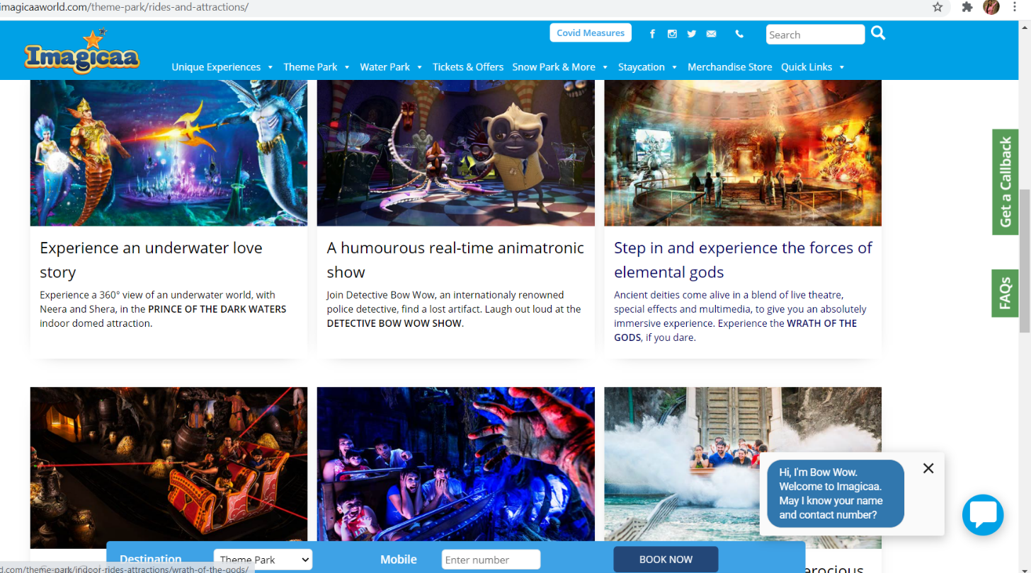

**TC12 : Click on Family rides button**

w.findElement(By.xpath("//button[contains(text(),'Family Rides')]")).click();

// Relative xpath

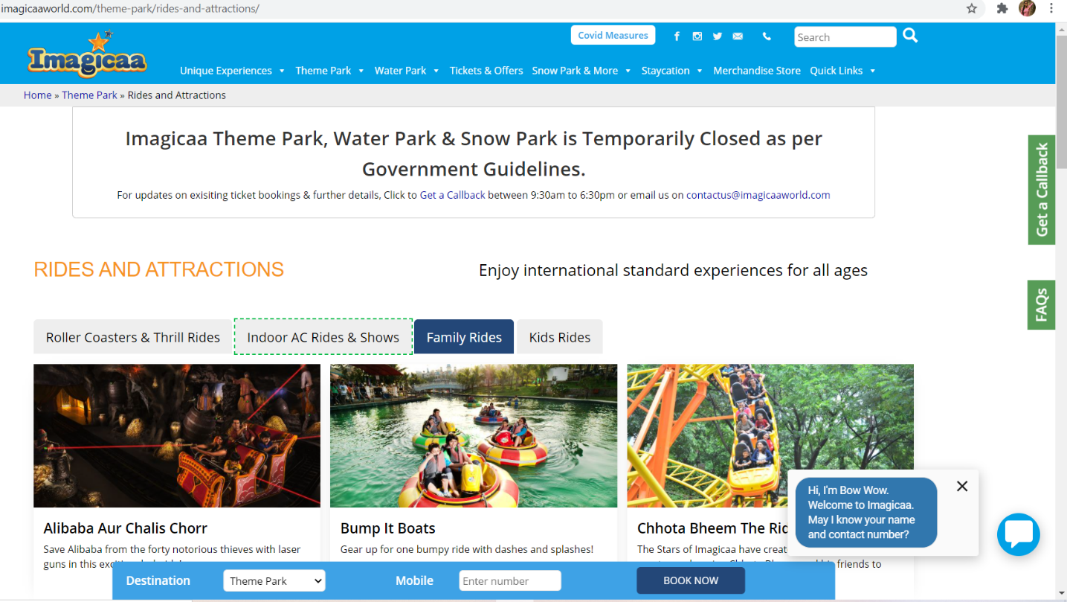

**TC13 :** **Scrolling Family rides**

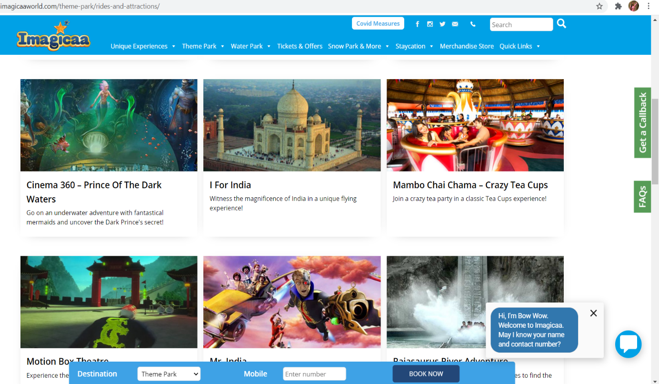

js.executeScript("window.scrollTo(0,400)");

Thread.sleep(2000);

js.executeScript("window.scrollTo(400,800)");

Thread.sleep(2000);

js.executeScript("window.scrollTo(800,0)");

Thread.sleep(2000);

**TC14 : Click on Kids rides button**

w.findElement(By.xpath("//button[contains(text(),'Kids Rides')]")).click();

// Relative xpath

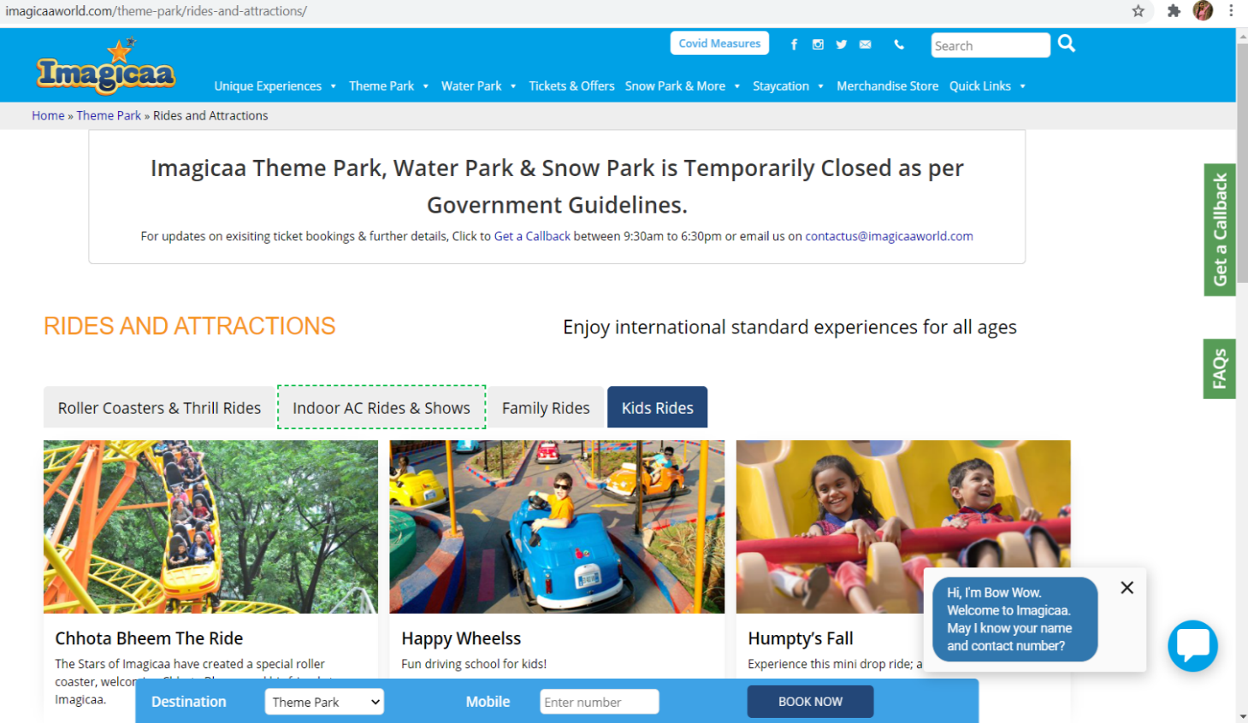

**TC15 :** **Scrolling Kids rides**

js.executeScript("window.scrollTo(0,400)");

Thread.sleep(2000);

js.executeScript("window.scrollTo(400,800)");

Thread.sleep(2000);

js.executeScript("window.scrollTo(800,0)");

Thread.sleep(2000);

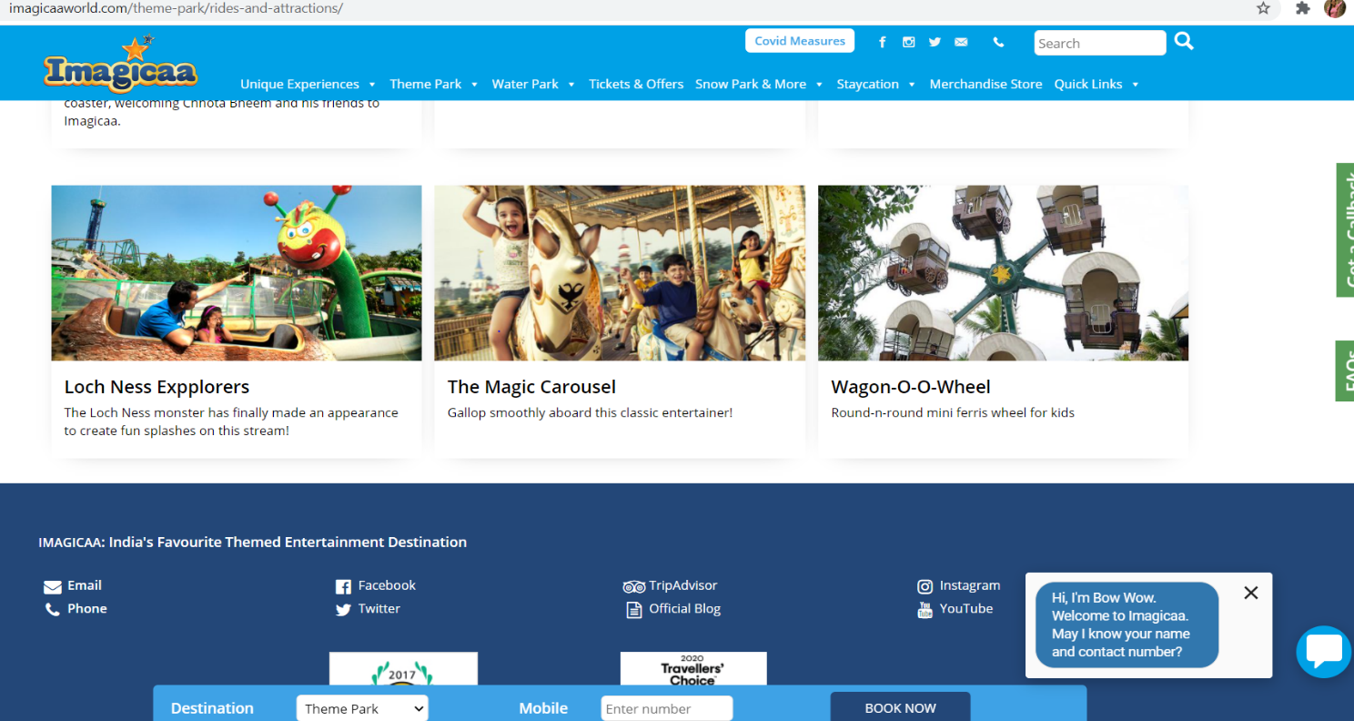

**TC16 : Mouse hover on navigation panes Theme Park**

act.moveToElement(w.findElement(By.linkText("Theme Park"))).perform();

Thread.sleep(2000);

**TC17: Click on Dining and drinks “Explore All” link**

// Click on Explore all we are using xpath for this because there is same locator for explore all

w.findElement(By.xpath("//body/div[@id='page']/div[@id='ae_header']/div[@id='ae_header--1']/div[1]/div[1]/div[1]/div[1]/div[1]/ul[1]/li[2]/ul[1]/li[3]/div[1]/ul[1]/li[4]/a[1]")).click();

Thread.sleep(2000);

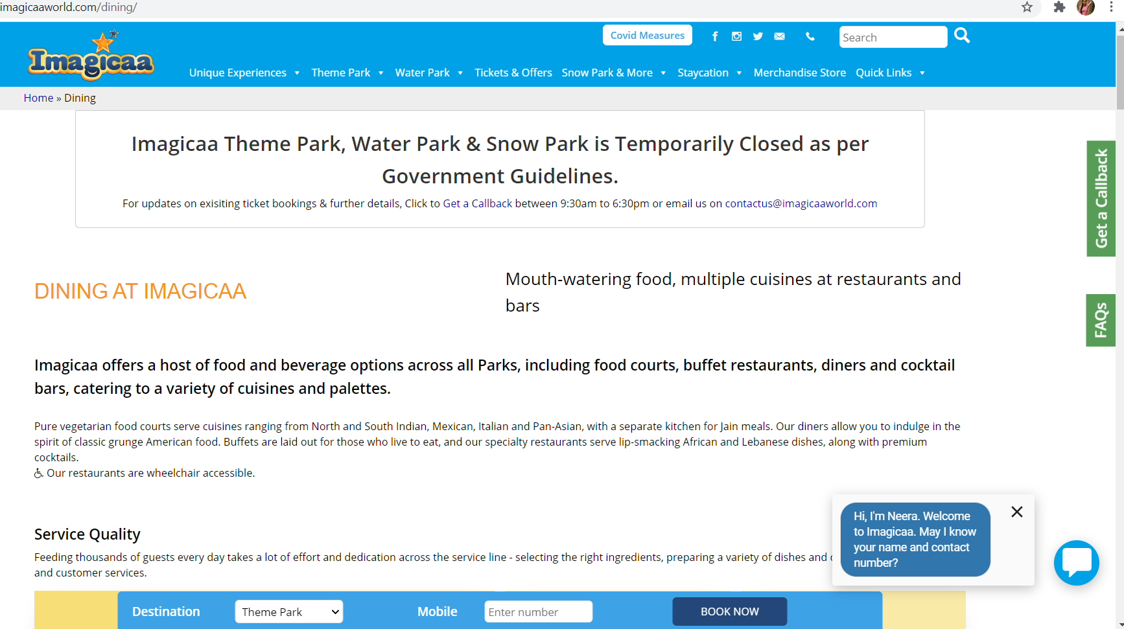

**TC18: Scrolling Dining and drinking page**

js.executeScript("window.scrollTo(0,500)");

Thread.sleep(2000);

js.executeScript("window.scrollTo(500,1000)");

Thread.sleep(2000);

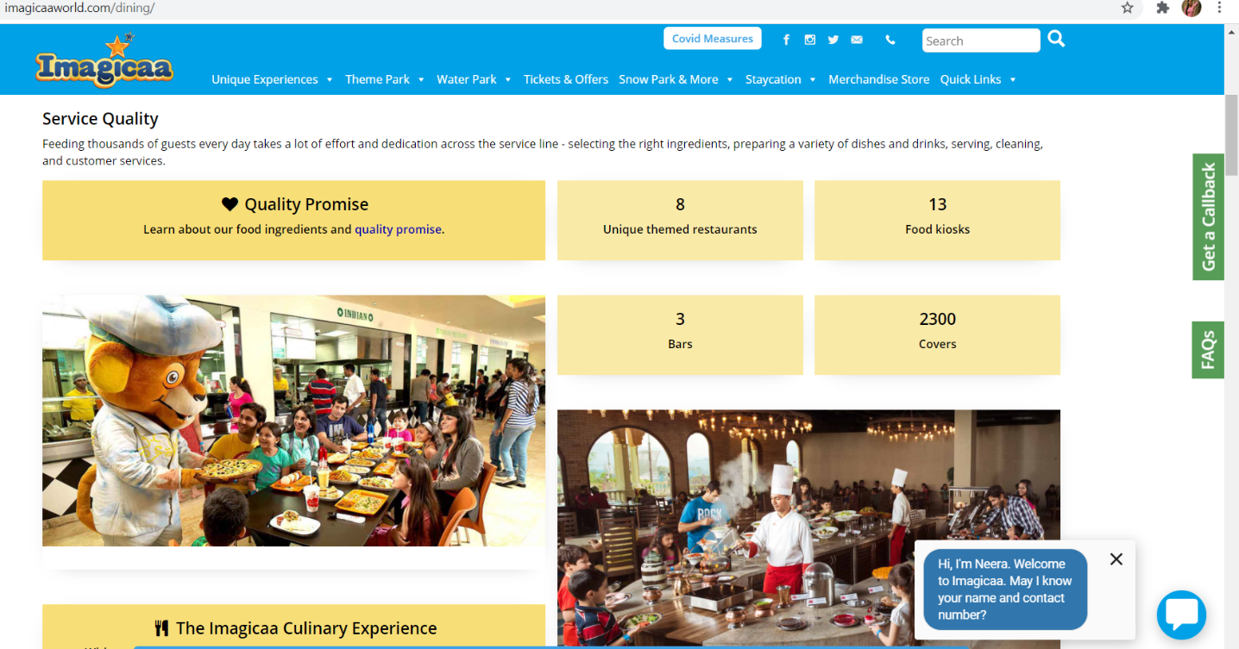

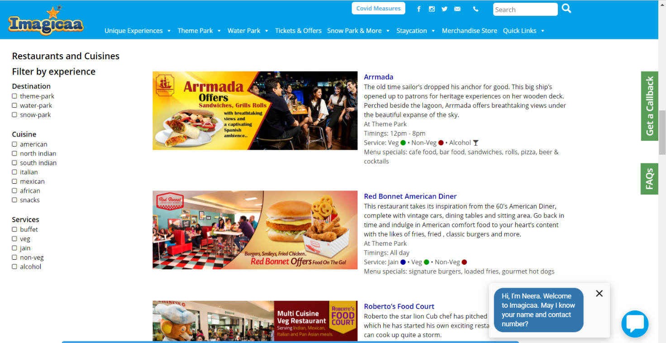

Defect : After scrolling at bottom of the page there is “Get the brochure” link after clicking on that link we get error message on screen

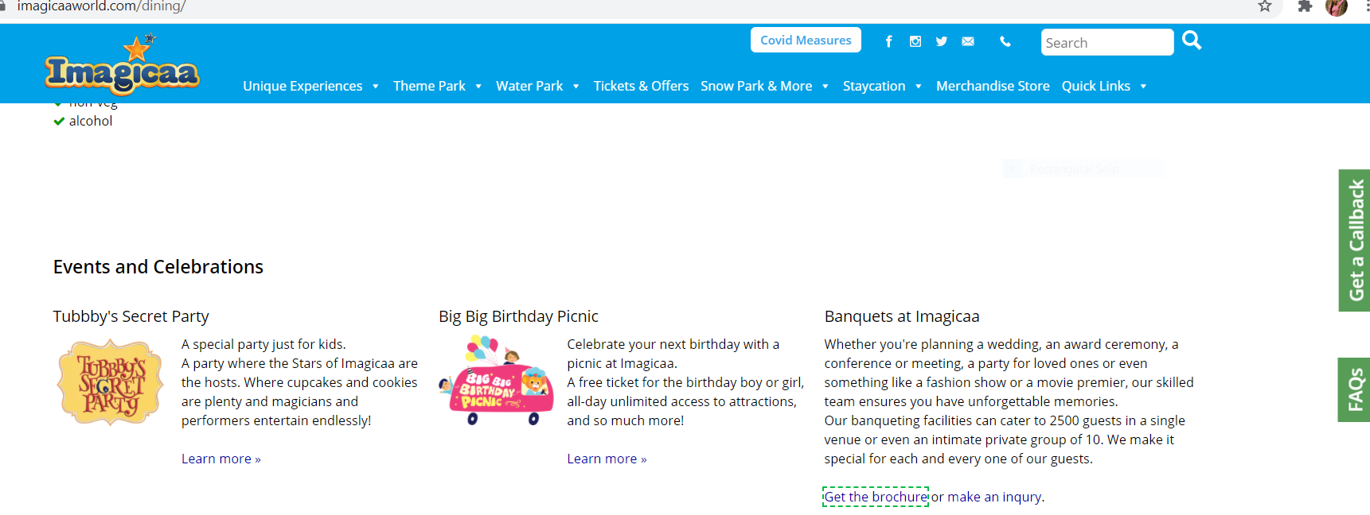

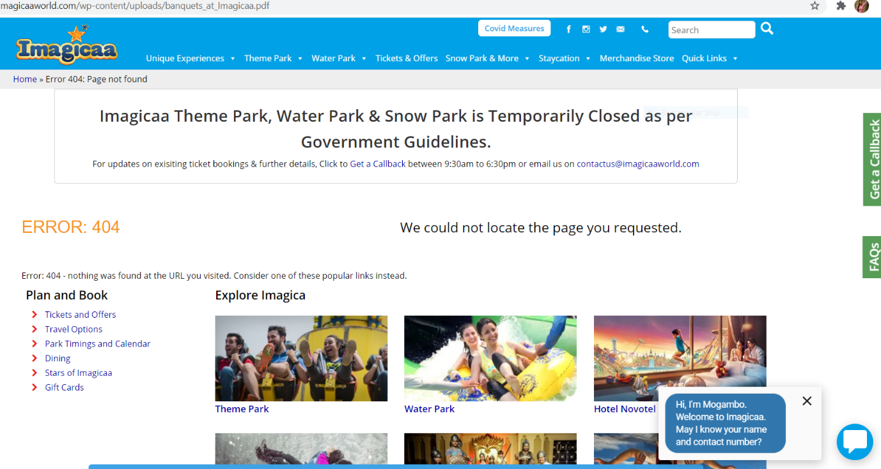

Expected result:  
It should be redirected to that page

Actual result:  
It is redirecting to another page and showing 404 Error

**TC19: Navigating to home page**

w.navigate().to("https://www.imagicaaworld.com/water-park/");

Thread.sleep(2000);

**TC20: Click on Instagram icon on home page**

w.findElement(By.xpath("/html[1]/body[1]/div[4]/div[3]/div[1]/div[1]/div[1]/div[2]/div[1]/ul[1]/li[2]/a[1]/img[1]")).click();

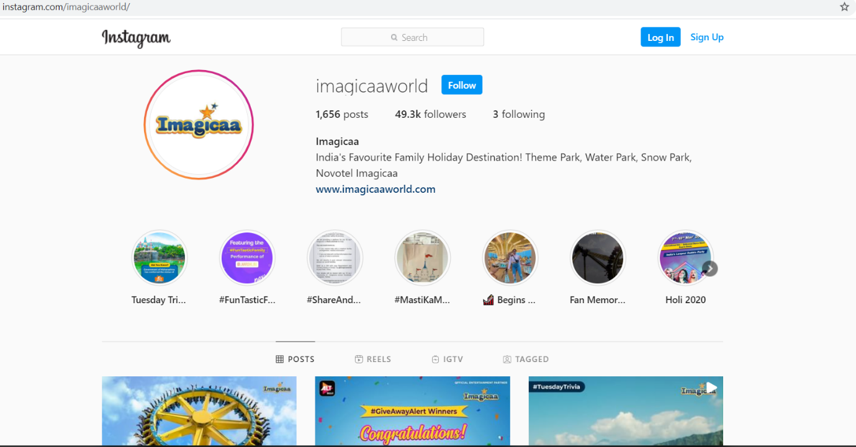

**TC21: Perform window handling**

Set <String> windows = w.getWindowHandles();

Iterator <String> it = windows.iterator();

String parent = it.next();

String child = it.next();

w.switchTo().window(child);

Thread.sleep(2000);

String str2 = w.getTitle();

System.out.println(str2);

w.close(); // Closing child window

w.switchTo().window(parent);

Thread.sleep(2000);

**TC22: Click on call icon on home page**

// click on call icon to open it

w.findElement(By.xpath("/html[1]/body[1]/div[4]/div[3]/div[1]/div[1]/div[1]/div[2]/div[1]/ul[1]/li[5]/a[1]/img[1]")).click();

Thread.sleep(3000);

// Again click on call icon to close it

w.findElement(By.xpath("/html[1]/body[1]/div[4]/div[3]/div[1]/div[1]/div[1]/div[2]/div[1]/ul[1]/li[5]/a[1]/img[1]")).click();

Thread.sleep(3000);

**TC23: Click on Get Callback button**

w.findElement(By.xpath("/html[1]/body[1]/div[4]/div[8]/div[2]")).click();

Thread.sleep(2000);

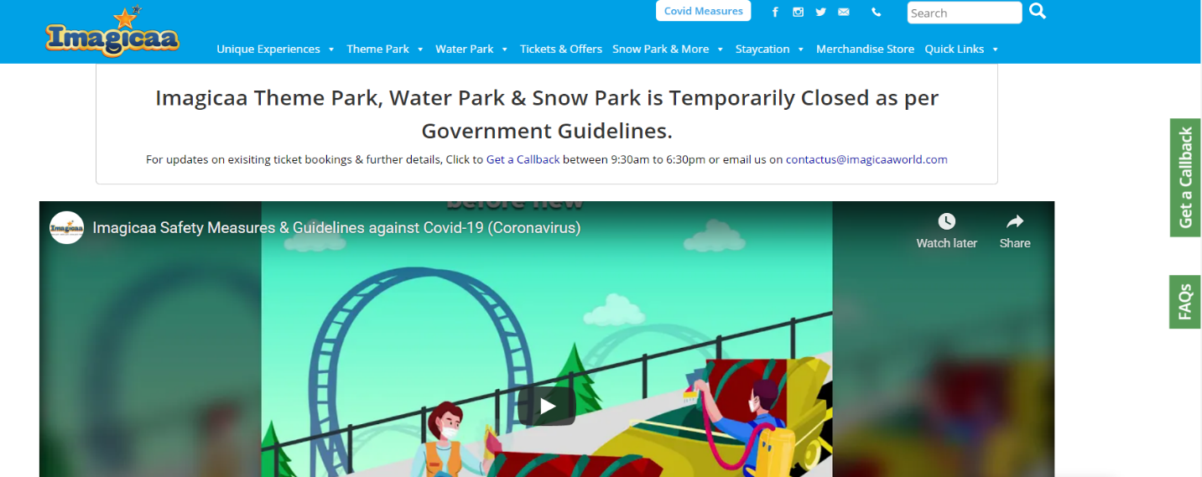

**TC24: Check the functionality of Get Callback button**

With valid data

w.findElement(By.name("full_name")).sendKeys("abc");

w.findElement(By.name("visit_date")).sendKeys("06-07-2021");

w.findElement(By.name("contact_number")).sendKeys("8928799162");

// Click checkbox for query

w.findElement(By.xpath("/html[1]/body[1]/div[4]/div[8]/div[4]/form[1]/div[1]/div[4]/div[1]/input[1]")).click();

w.findElement(By.name("btnSubmit")).click();

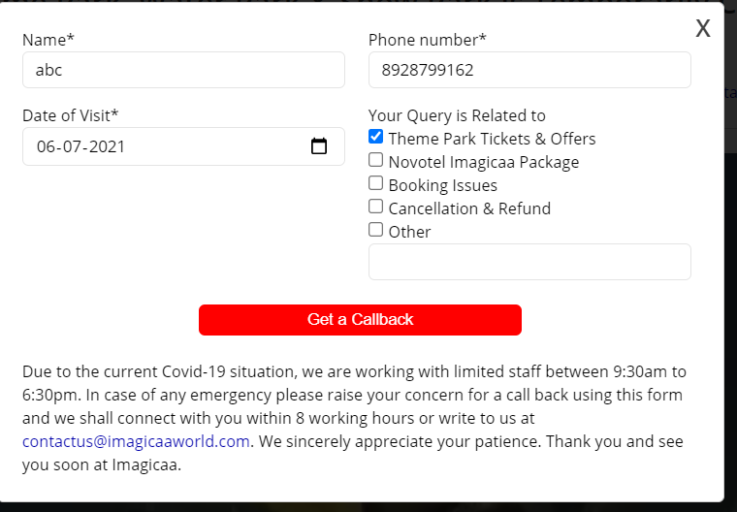

With invalid data

w.findElement(By.name("full_name")).sendKeys(" ");

w.findElement(By.name("visit_date")).sendKeys("06-02-1978");

w.findElement(By.name("contact_number")).sendKeys("0");

// Click checkbox for query

w.findElement(By.xpath("/html[1]/body[1]/div[4]/div[8]/div[4]/form[1]/div[1]/div[4]/div[1]/input[1]")).click();

w.findElement(By.name("btnSubmit")).click();

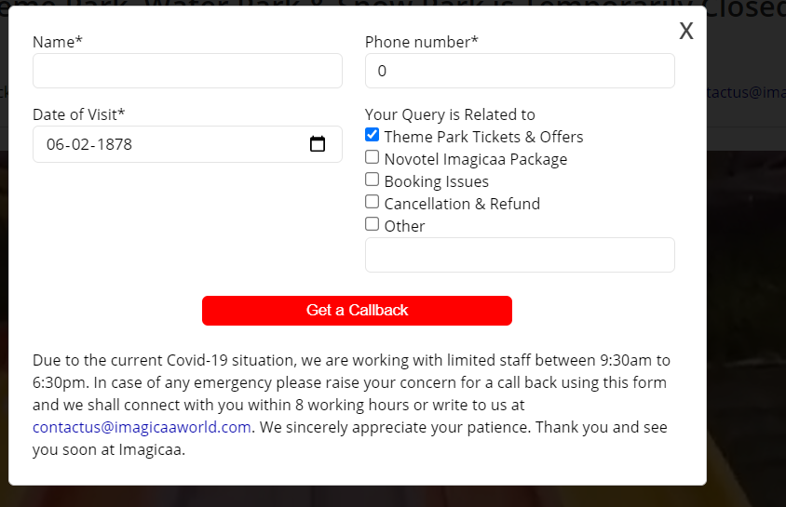

Defect : With invalid data

Expected Result:  
"Enter valid name" validation message should be display  
"Enter valid phone number" validation message should be display

Actual Result:  
It is redirecting to get call back page and showing message "Thanks for submission"

**TC25: Perform window handling on get callback page**

Set <String> windows1 = w.getWindowHandles();

Iterator <String> it1 = windows1.iterator();

String parent1 = it1.next();

String child1 = it1.next();

w.switchTo().window(child1);

Thread.sleep(2000);

w.switchTo().window(parent1);

Thread.sleep(1000);

w.switchTo().window(child1);

Thread.sleep(1000);

// closing the child window

w.close();

w.findElement(By.xpath("//body/div[@id='page']/div[@id='content']/div[4]/div[1]")).click();

Thread.sleep(2000);

parent window



Child window

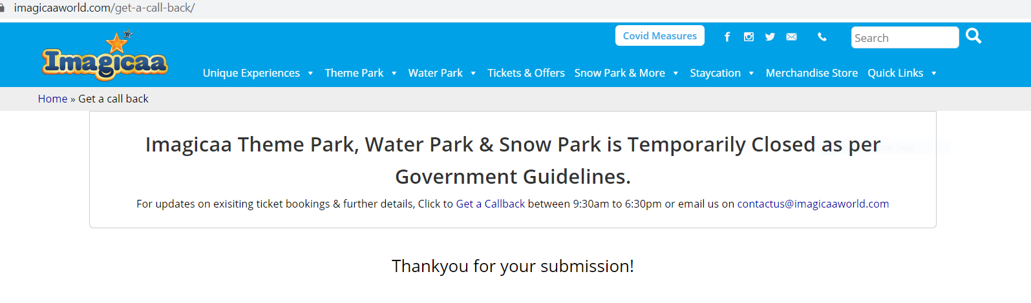

**TC26: Click on FAQ button on homepage**

w.findElement(By.*xpath*("/html[1]/body[1]/div[4]/div[8]/div[5]")).click();

Thread.*sleep*(1000);

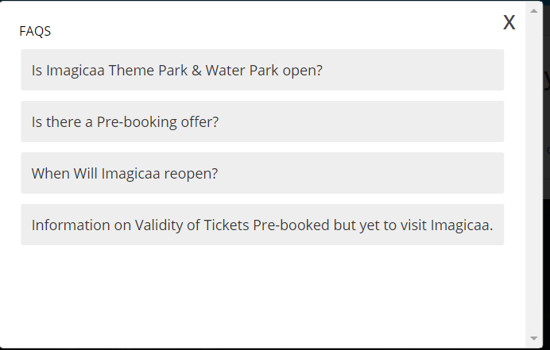

**TC27: Checking each link of FAQ**

w.findElement(By.linkText("Is Imagicaa Theme Park & Water Park open?")).click();

Thread.sleep(1000);

w.findElement(By.partialLinkText("Is there a Pre-booki")).click();

Thread.sleep(1000);

w.findElement(By.partialLinkText("When Will Imagicaa r")).click();

Thread.sleep(1000);

w.findElement(By.partialLinkText("Information on Valid")).click();

Thread.sleep(1000);

**TC28: Scrolling up for FAQ**

JavascriptExecutor js = (JavascriptExecutor) w;

js.executeScript("window.scrollTo(document.body.scrollHeight,0)");

Thread.sleep(1000);

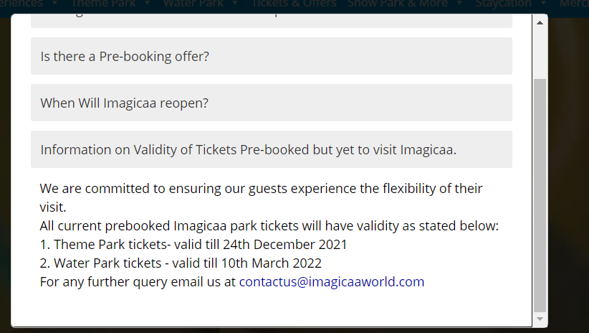

**TC29: Click on close button of FAQ**

w.findElement(By.xpath("/html[1]/body[1]/div[4]/div[8]/div[7]/div[1]")).click();

Thread.sleep(3000);

**TC30: Click on search icon of home page with blank input**

w.findElement(By.xpath("//body/div[@id='page']/div[@id='ae_header']/div[@id='ae_header--2']/div[1]/div[1]/div[3]/form[1]/button[1]/*[1]")).click();

Thread.sleep(3000);

JavascriptExecutor js = (JavascriptExecutor) w;

js.executeScript("window.scrollTo(0,1000)");

Thread.sleep(3000);

js.executeScript("window.scrollTo(1000,0)");

Thread.sleep(1000);

w.navigate().back();

Thread.sleep(1000);

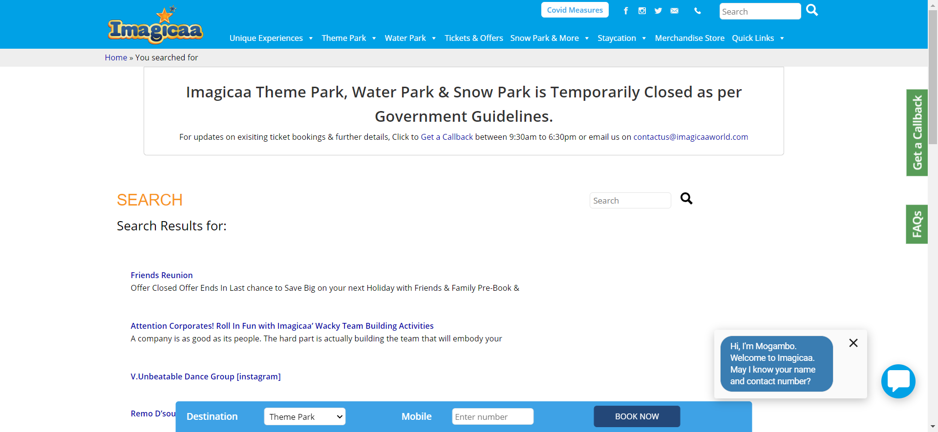

Defect : With blank data

Expected result :  
Search button should be disable for blank input

Actual Result :  
It is redirecting on search page and showing results

**TC31: Check the functionality of book now button**

Select s = new Select(w.findElement(By.className("bookingWidgetSelect")));

s.selectByValue("theme_park");

Thread.sleep(1000);

w.findElement(By.name("mobile_num")).sendKeys("8928799162");

w.findElement(By.id("widgetActionButton")).click();

Thread.sleep(2000);

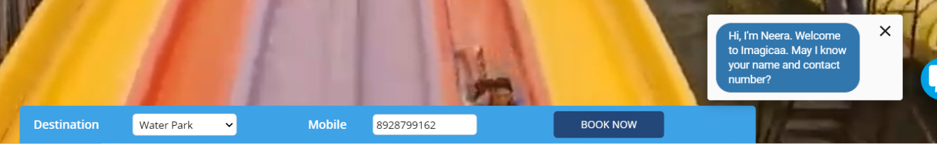

**TC32: Scrolling select destination package page at bottom**

JavascriptExecutor js = (JavascriptExecutor) w;

js.executeScript("window.scrollTo(document.body.scrollHeight,0)");

Thread.sleep(1000);

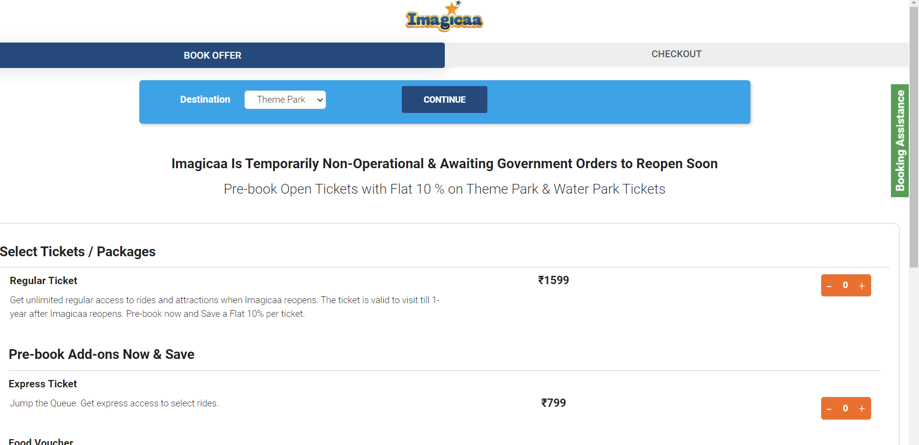

**TC33: Click on proceed to checkout button**

With valid data

w.findElement(By.id("name")).sendKeys("abc");

w.findElement(By.id("proceed-checkout")).click();

Thread.sleep(1000);

#### 

Defect : With blank data (Name with spaces)

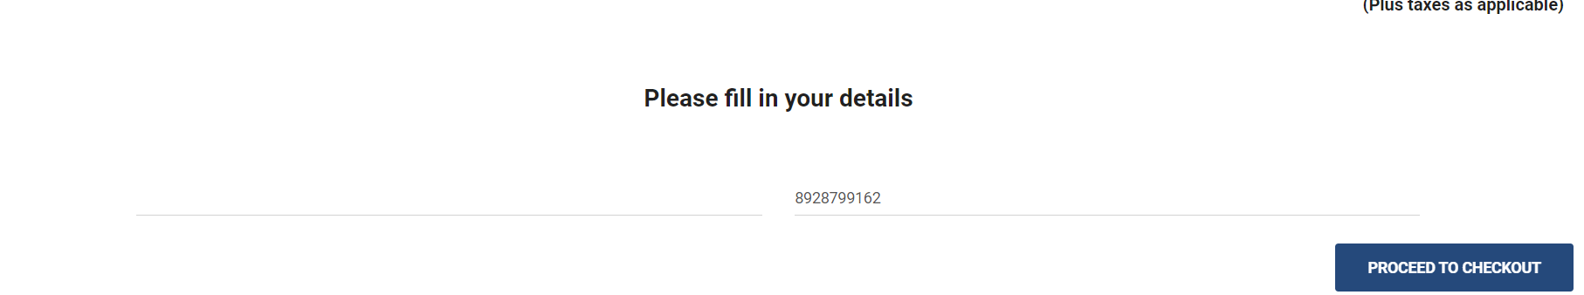

Expected Result:  
"Enter valid name " message should be display

Actual Result :  
It is redirected to checkout page after clicking on proceed to checkout button

Defect : “Proceed to checkout” button is working without selecting any package

Expected Result:  
"Select any package" message should be display or proceed to checkout button should be disabled

Actual Result:   
Redirected to checkout page

Defect : “Proceed to checkout” button is working with invalid mobile number

Expected Result:  
"Enter valid mobile number" validation message should be display

Actual Result :   
Redirected to checkout page

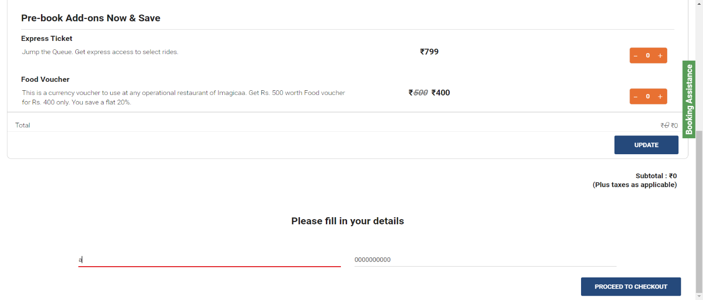

**TC34: Click on submit button**

With valid data

w.findElement(By.id("email")).sendKeys("sejkar@gmail.com");

w.findElement(By.id("dob")).sendKeys("28-02-1997");

w.findElement(By.id("pincode")).sendKeys("422048");

js.executeScript("window.scrollTo(document.body.scrollHeight,0)");

Thread.sleep(1000);

w.findElement(By.id("btnSubmit")).click();

Thread.sleep(1000);

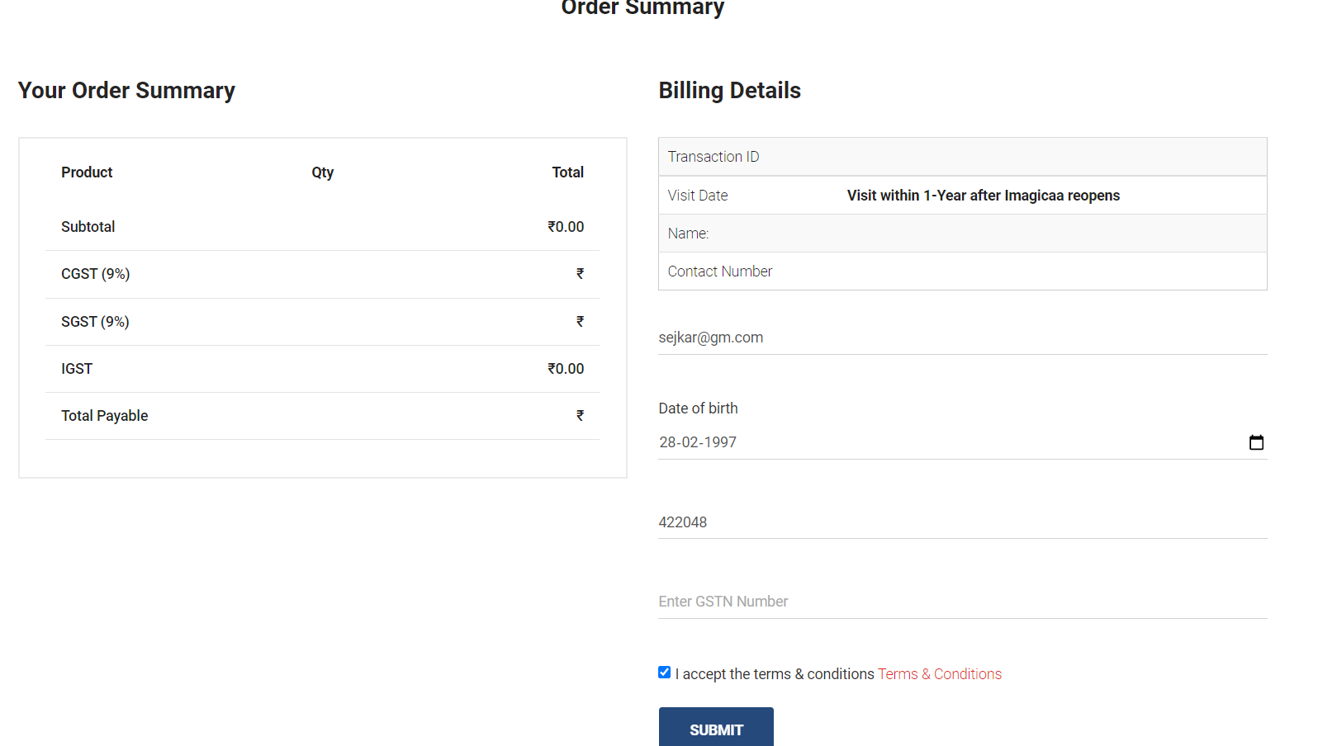

Defect: “Submit” button working with (invalid zip code and date of birth)

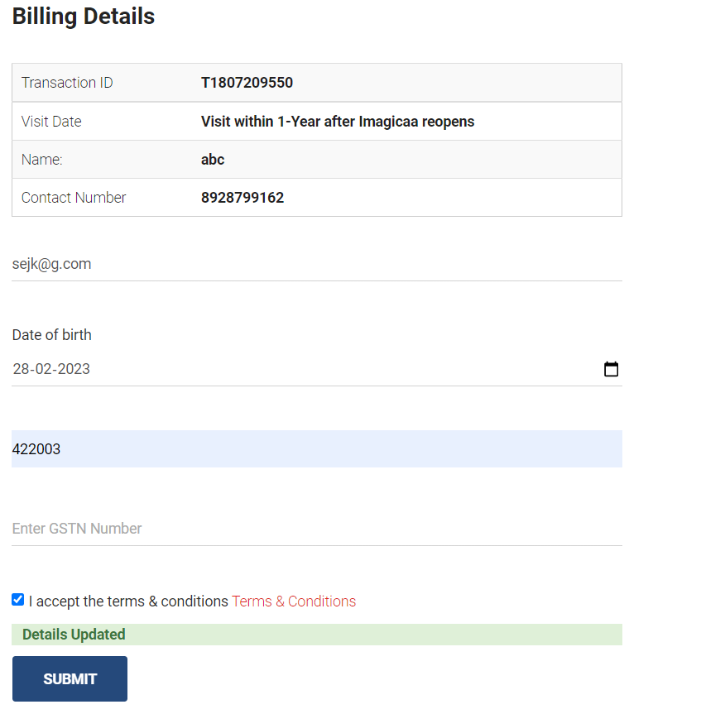

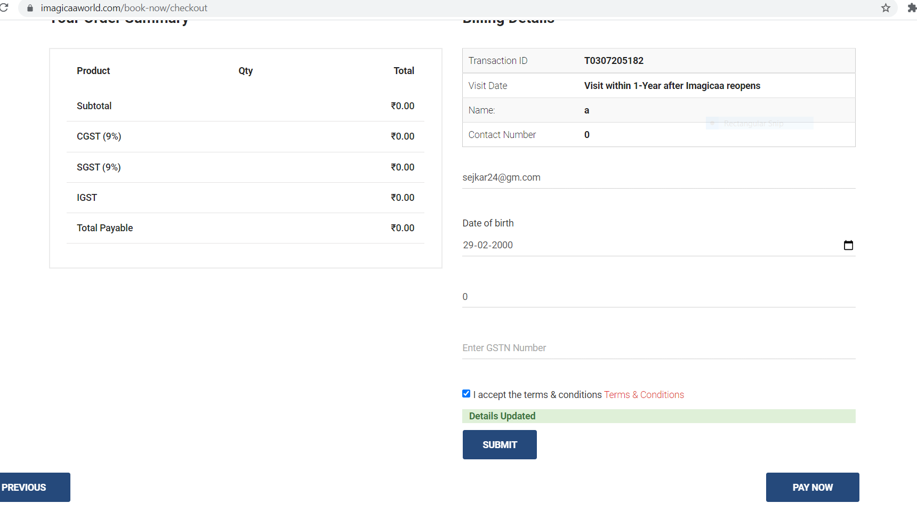

Expected Result:  
"Enter valid zip code" validation message should be display  
"Enter valid date of birth " validation message should be display

Actual Result:  
"Details updated" message is display

**TC35: Click on Tickets and offers link**

w.findElement(By.linkText("Tickets & Offers")).click();

Thread.sleep(2000);

**TC36: Click on Novtel stay + All day meals link**

JavascriptExecutor js = (JavascriptExecutor) w;

js.executeScript("window.scrollTo(0,400)");

Thread.sleep(2000);w.findElement(By.xpath(

"/html[1]/body[1]/div[4]/div[8]/div[8]/main[1]/article[1]/div[1]/div[2]/div[1]/div[2]/div[3]/div[2]/div[3]/div[1]/div[1]/div[2]/a[1]/h2[1]")).click();

Thread.sleep(2000);

**TC37: Click on Prebook the package here link**

js.executeScript("window.scrollTo(0,1500)");

Thread.sleep(2000);

w.findElement(By.xpath("//a[contains(text(),'Pre-book the Package here')]")).click();

Thread.sleep(5000);

Defect: “Prebook the package” link is not working.

Expected Result:  
It should be redirected to another page

Actual Result:  
It is showing light black window and not redirected to other page

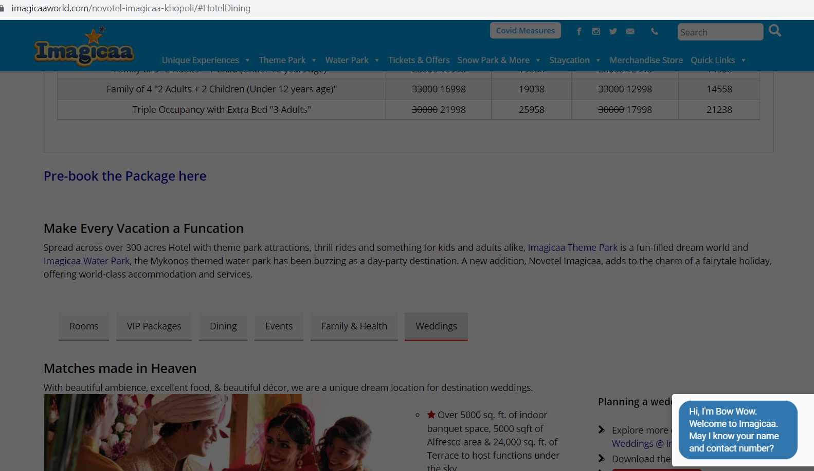

**TC38: Refresh the page**

w.navigate().refresh();

Thread.sleep(1000);

**TC39: Click on weddings list item**

js.executeScript("window.scrollTo(1500,1600)");

Thread.sleep(1000);

w.findElement(By.xpath("//li[@id='toggleTabHotelWeddings']")).click();

Thread.sleep(1000);

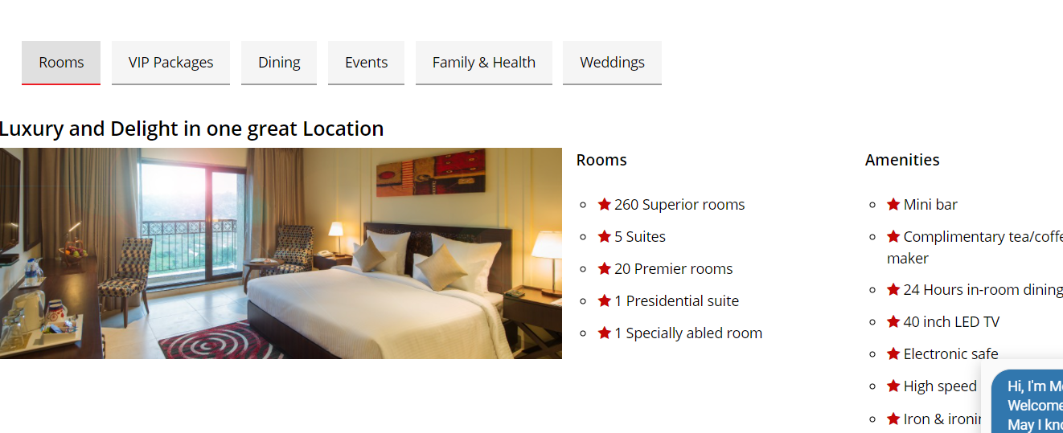

**TC40: Click on submit and inquiry button**

w.findElement(By.xpath(

"/html[1]/body[1]/div[4]/div[8]/div[8]/main[1]/article[1]/div[1]/div[2]/div[1]/div[3]/div[7]/div[2]/div[1]/div[6]/div[1]/div[2]/div[1]/div[2]/ul[1]/li[3]/a[1]/strong[1]")).click();

Thread.sleep(2000);

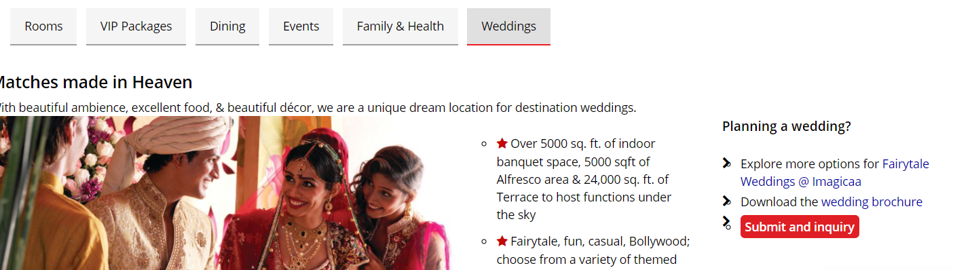

**TC41: Click on send inquiry button**

w.findElement(By.cssSelector("input[name = 'Name']")).sendKeys("divya");

Thread.sleep(1000);

w.findElement(By.cssSelector("input[name = 'Email']")).sendKeys("s@gmail.com");

Thread.sleep(1000);

w.findElement(By.cssSelector("input[name = 'Phone']")).sendKeys("8928799162");

Thread.sleep(1000);

w.findElement(By.cssSelector("input[name = 'Event Date']")).sendKeys("24-07-2021");

Thread.sleep(1000);

w.findElement(By.name("Event Type")).click();

Thread.sleep(1000);

w.findElement(By.id("inquirySubmit")).click();

Thread.sleep(2000);

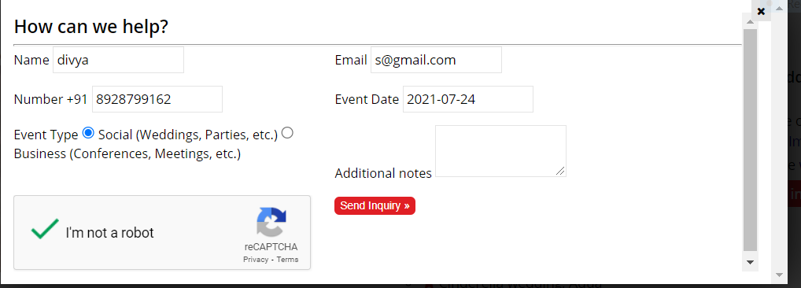

Defect: “Send inquiry” button is not showing any validation message for invalid data

Expected Result :  
"Enter valid name " validation message should be display.  
"Enter valid email" validation message should be display.  
"Enter valid phone number" validation message should be display.

Actual Result:  
validation message is not displaying

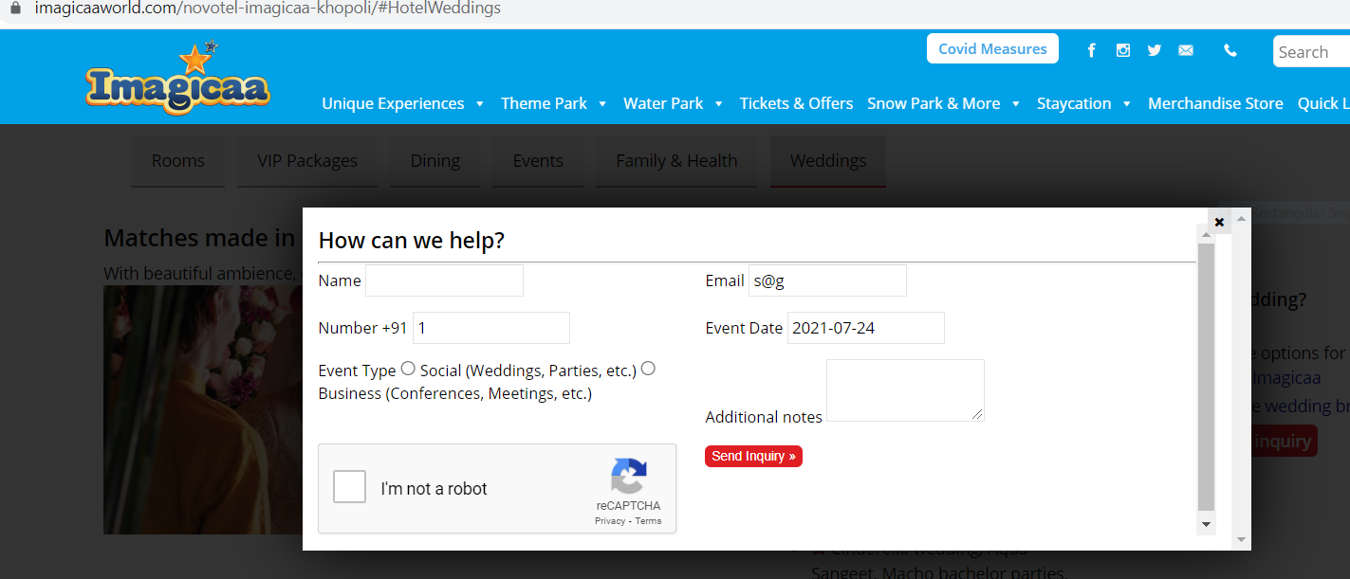

Defect: “How can we help?” form date format is “dd-mm-yyyy” it is showing “yyyy-mm-dd” and not working with send inquiry button

Expected Result:

Event date should be display like 24-07-2021 ("dd-mm-yyyy" format)

Actual Result:  
Event date is displaying 2021-07-24   
"Please match the requested format" message is displaying

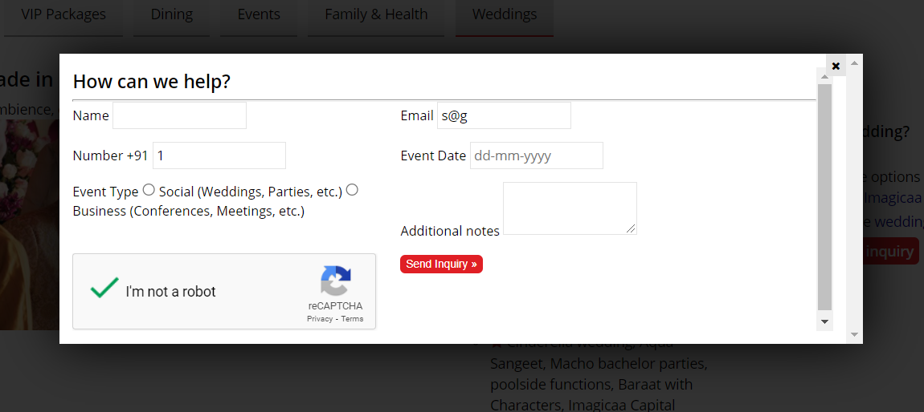

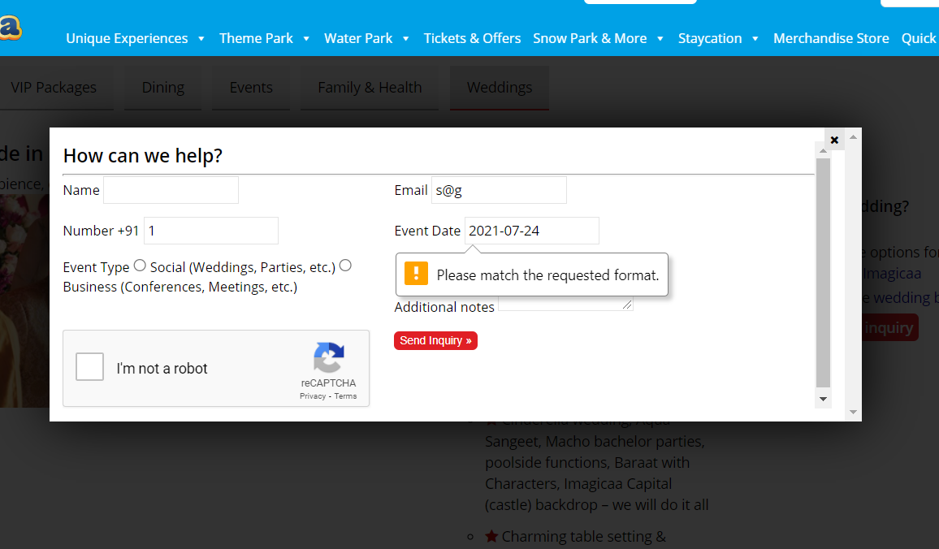

For user this form will not submit because of this issue

**TC42: Mouse hovering on Quick links**

act = new Actions(w);

act.moveToElement(w.findElement(By.linkText("Quick Links"))).perform();

Thread.sleep(1000);

**TC43: Click on Schools & Institutions**

w.findElement(By.linkText("Schools & Institutions")).click();

Thread.sleep(1000);

**TC44: Click on Submit and inquiry button**

w.findElement(By.xpath(

"//body[1]/div[4]/div[8]/div[8]/main[1]/article[1]/div[1]/div[2]/div[1]/div[1]/div[2]/a[1]/ul[1]/li[1]")).click();

Thread.sleep(1000);

**TC45: Check the functionality of send inquiry button**

**With valid data**

w.findElement(By.name("Name")).sendKeys("abc");

w.findElement(By.name("Email")).sendKeys("a@gmail.com");

w.findElement(By.name("Phone")).sendKeys("8999999999");

w.findElement(By.name("Visit_Date")).sendKeys("24-07-2021");

Select city = new Select(w.findElement(By.name("City")));

city.selectByValue("Bhusawal");

w.findElement(By.name("Company")).sendKeys("MNP School");

w.findElement(By.name("Guests")).sendKeys("50");

Select desti = new Select(w.findElement(By.name("Destination")));

desti.selectByVisibleText("Snow Park");

Thread.sleep(1000);

w.findElement(By.id("inquirySubmit")).click();

Thread.sleep(2000);

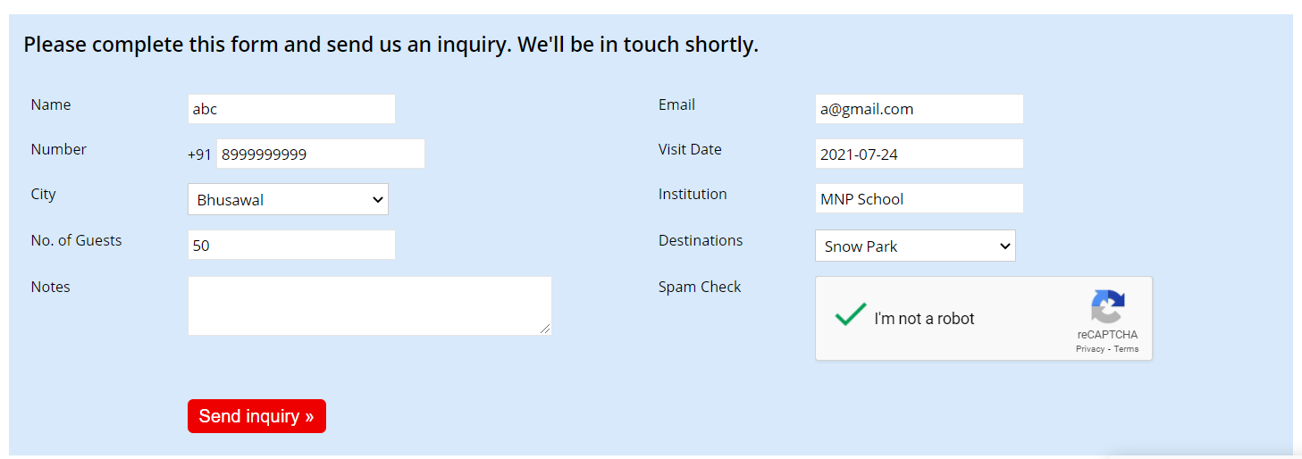

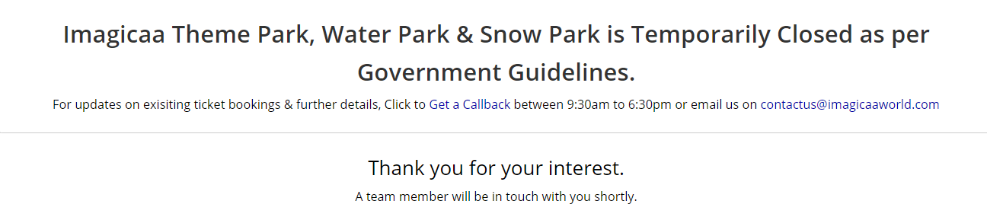

Defect: “Send inquiry” button is working with invalid name , Email and Institution

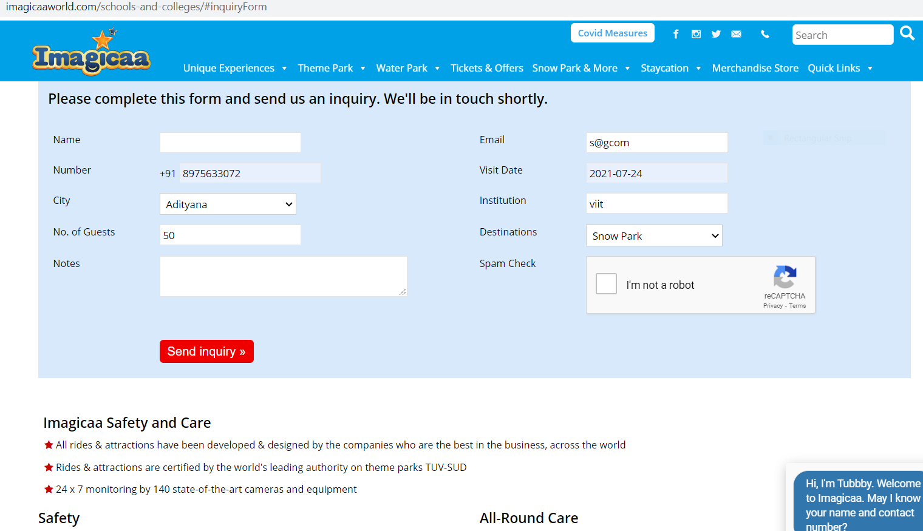

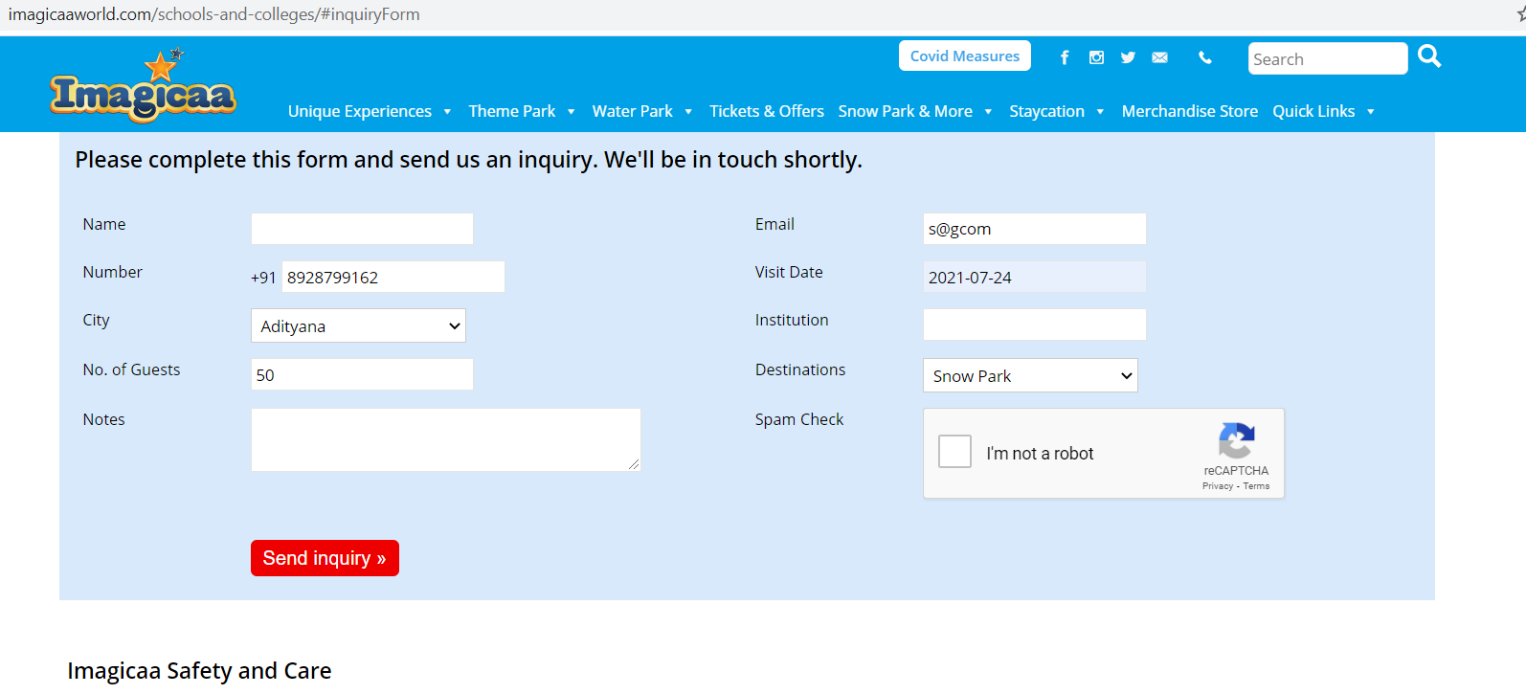

Expected result:  
"Enter characters or filed is empty" validation message should be display

“Enter valid email address” message should be display

Actual Result:  
form is submitted and it is redirected to thanks page

**TC46: Accepting the alert message**

Alert a = w.switchTo().alert();

a.accept();

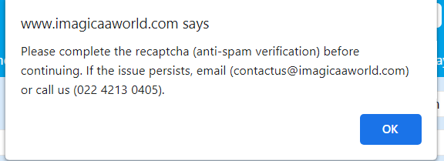

**TC47: Close the browser**

w.close();

Defects

On Home page "Quick info " section 2 images with click are not working

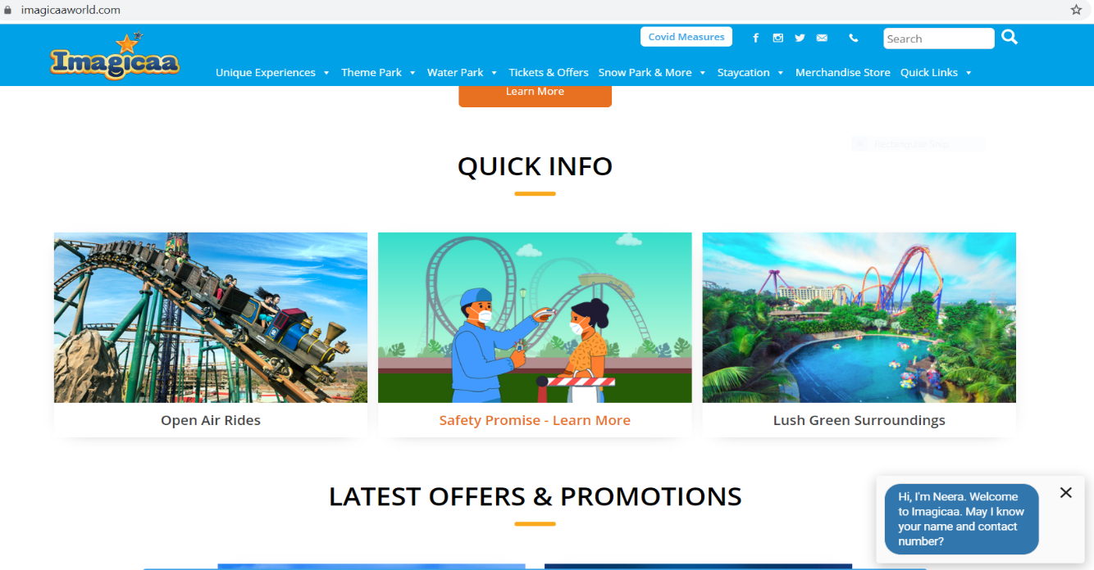

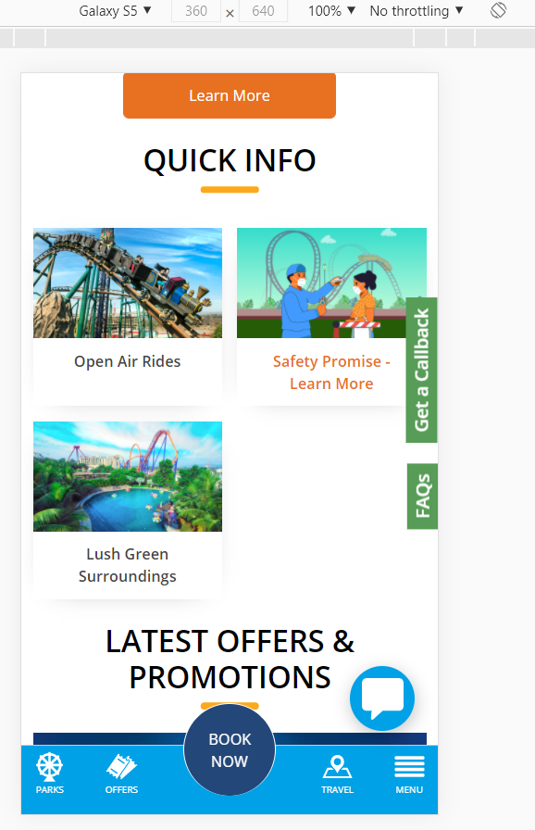

Expected result:  
When user click on those images It should be redirect to respective pages

Actual result:  
On click it is not redirected to any page

On hover it is showing: javascript : void(0)

unnecessary icons on homepage latest offers section

**Unnecessary icon "->" is there it is having no use and not looking user friendly.**

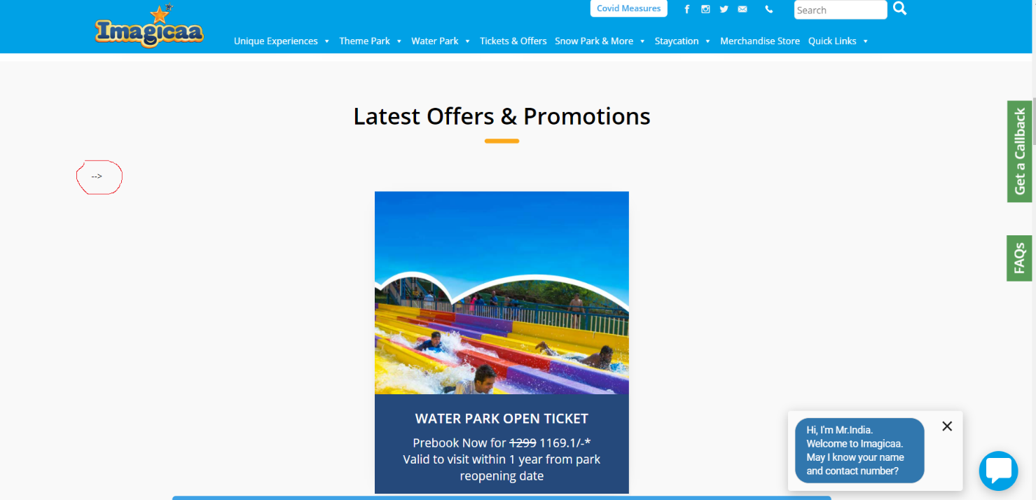

**"Party and Entertainment" image contents overlapping on "Explore Essential Add-on"**

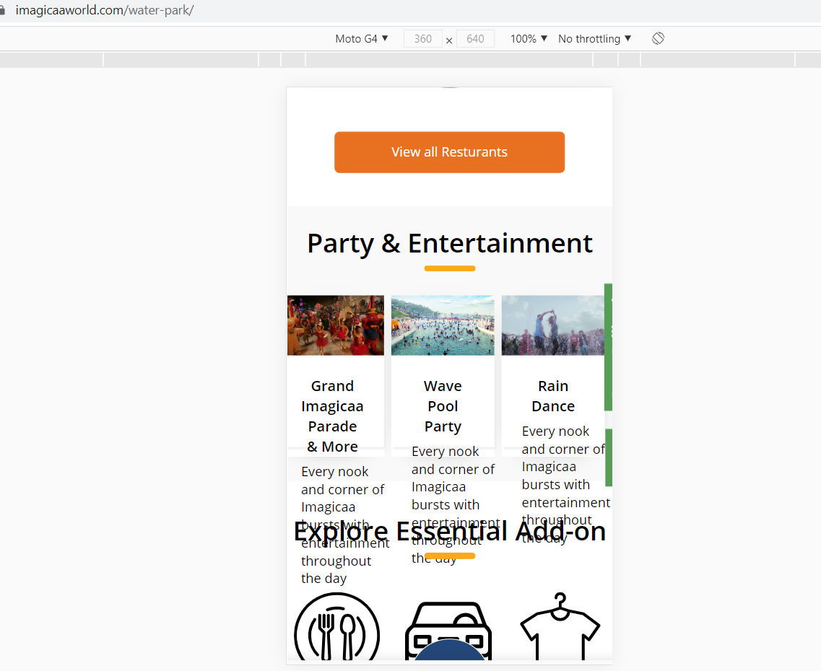

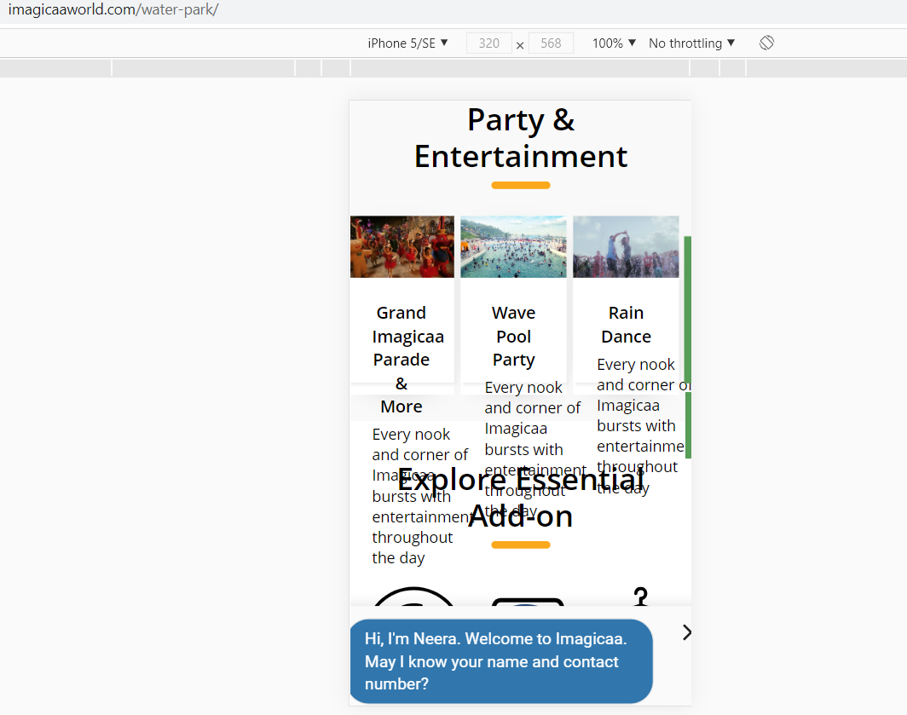

**"Latest offers and promotions" contents overlapping on "Latest update"**

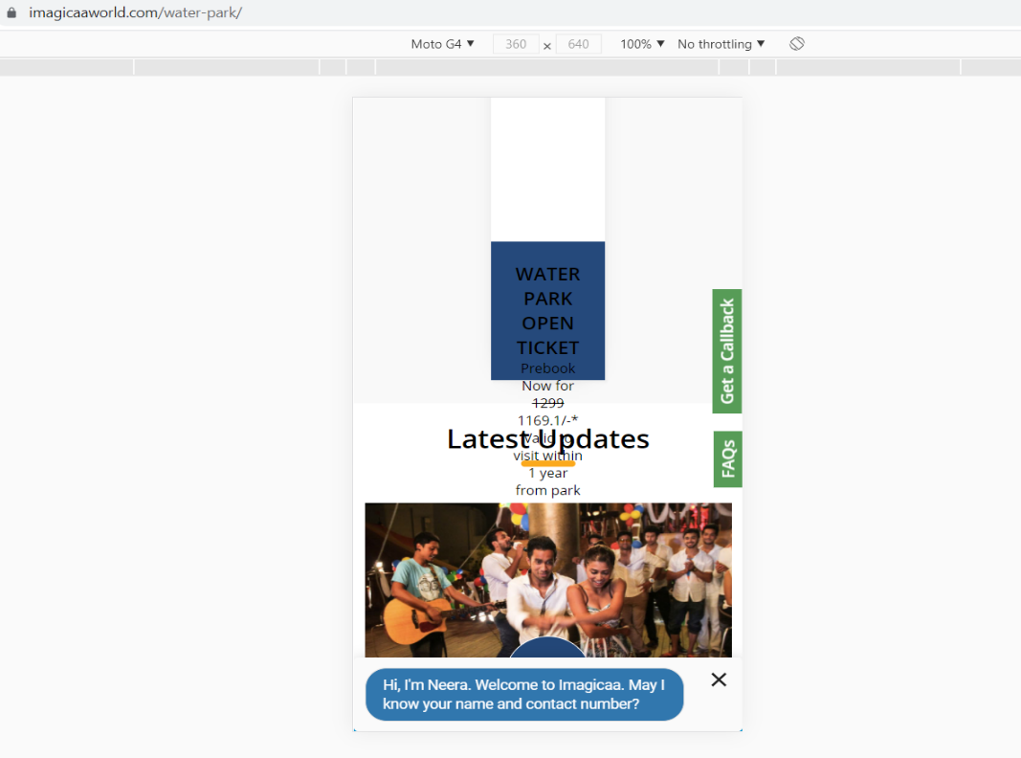

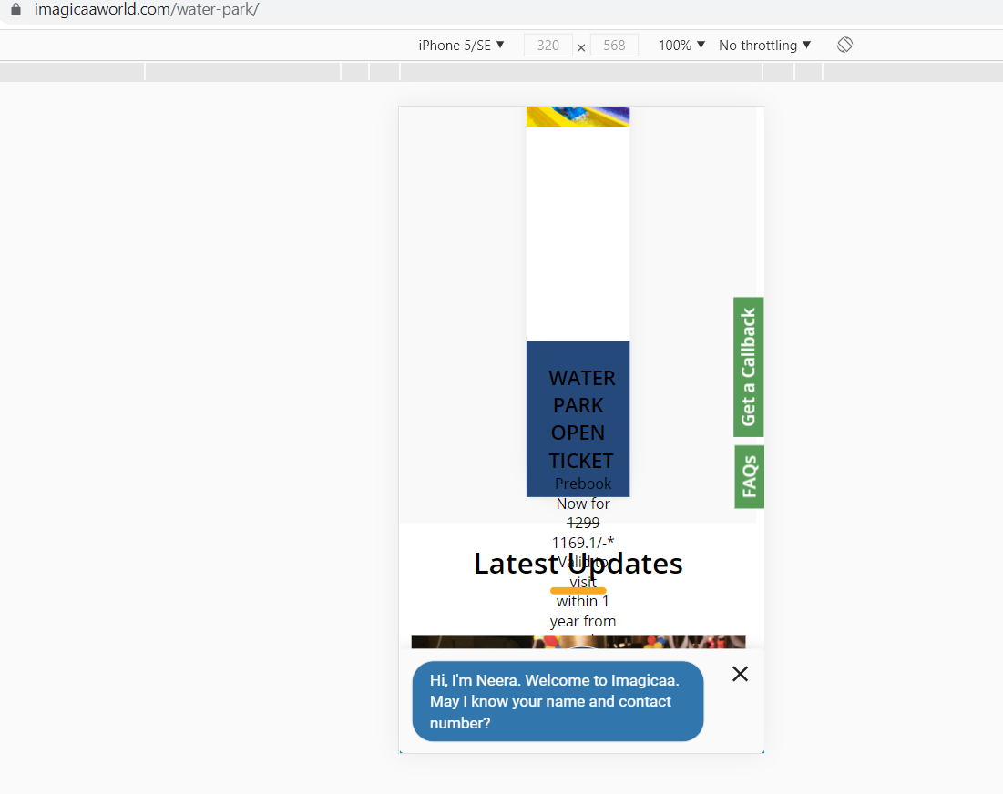

**"Submit" button of blogs page is working with invalid email id**

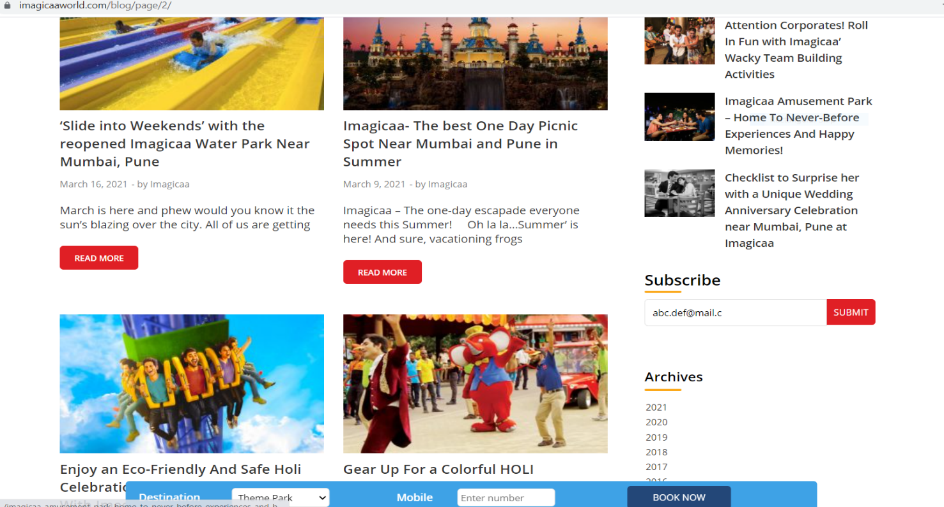

At Subscribe section Enter invalid email : [abc.def@mail.c](mailto:abc.def@mail.c)

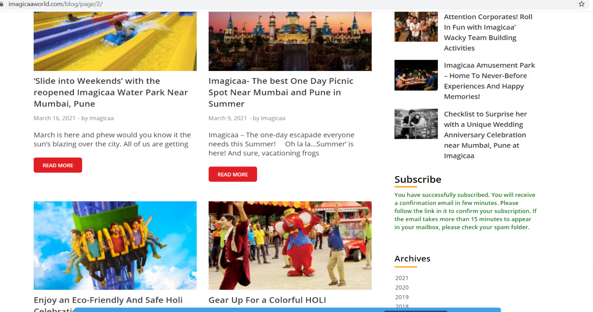

**On "Blogs page" at bottom "Next" button having alignment issue**

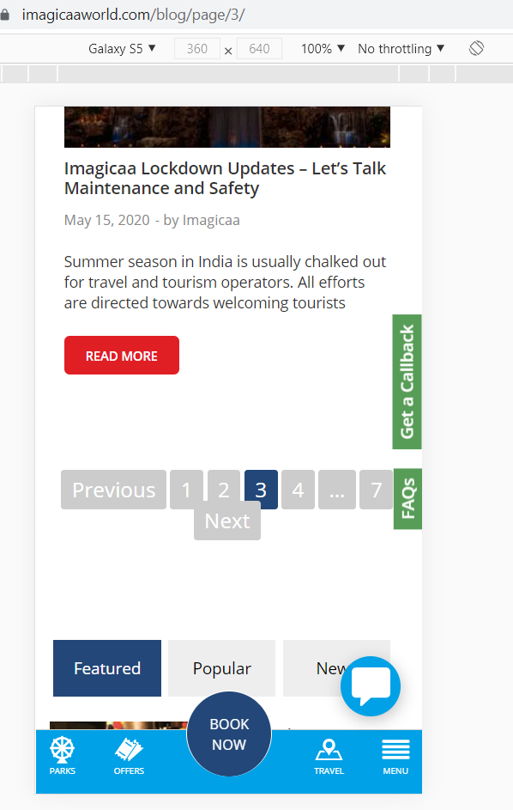

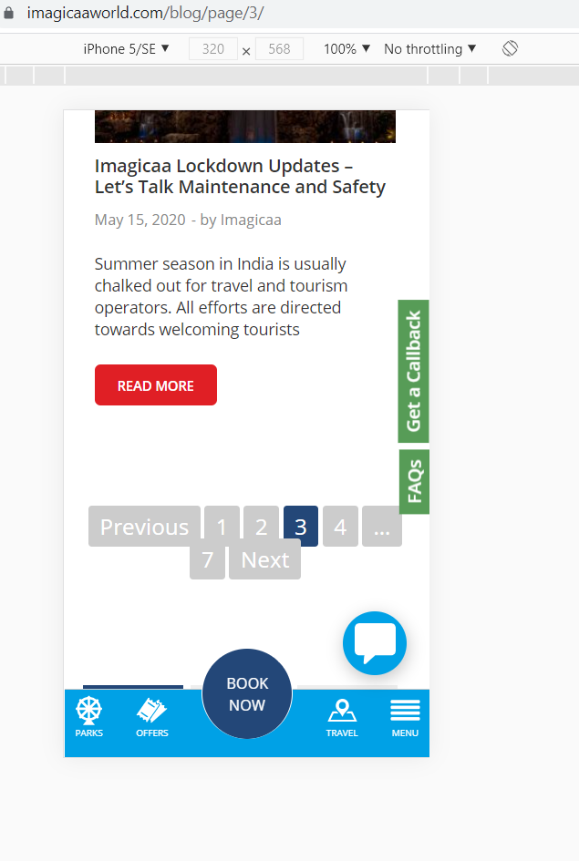

**On home page in navigation pane call icon panel alignment issue**

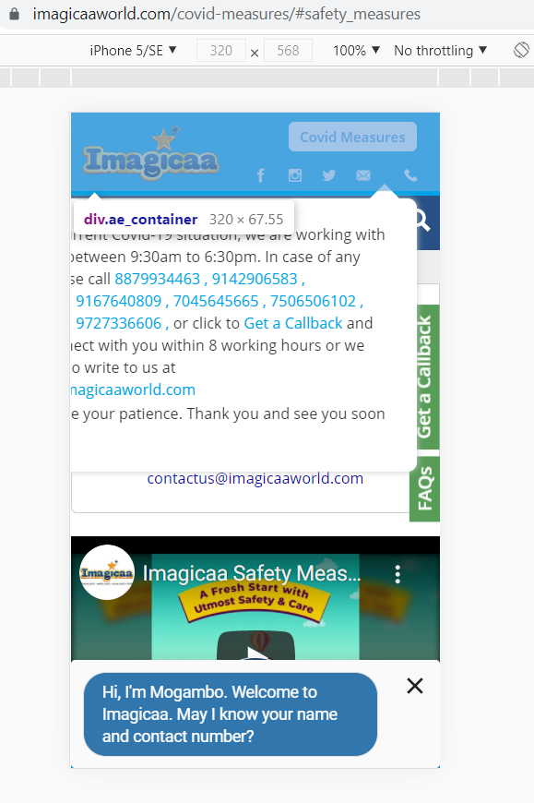

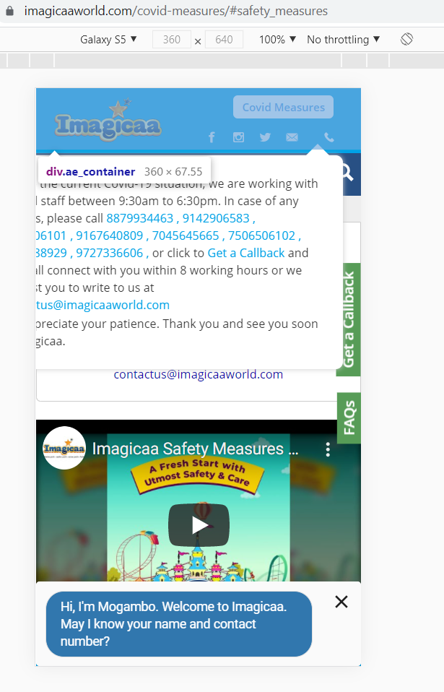

**"Covid Measures" page buttons text is displaying out of button**

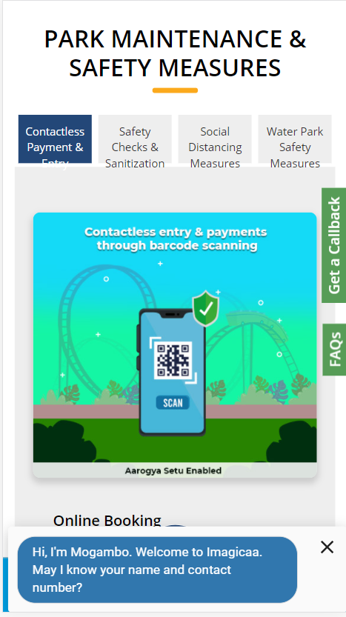

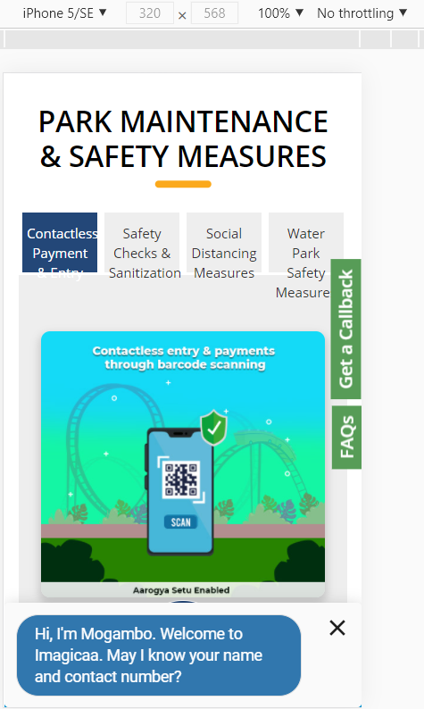

**All the defects are raised on jira tool**

